|  |  |
| --- | --- |
| **Query** | **Report** |
| * **Selecting fields** * **Search criteria** * **Calculated field + formatting** * **Report title** | * **Sort** * **Report header/footer** * **Calculation (count,sum,max,min)** * **Labels for formulas** * **Page orientation** * **Show labels in full** |

**Delivered Price:[Cost Price]+200**

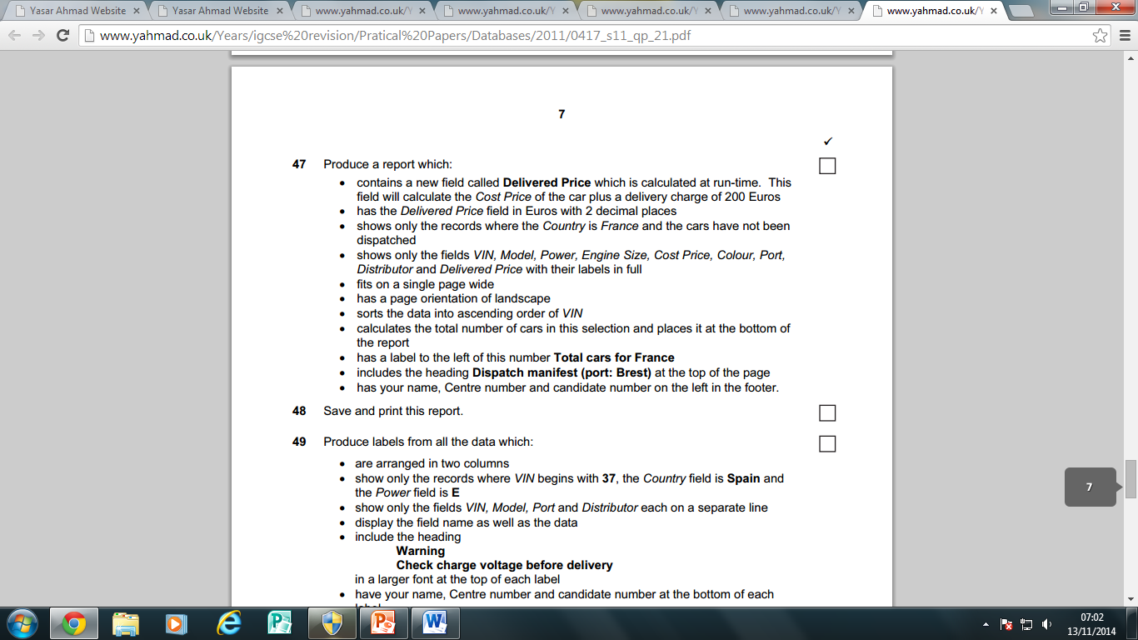

**R**

**Q**

**Q**

**Q**

**Q**

**Q**

**R**

**R**

**R**

**R**

**R**

**Search Criteria**

Country – **France**

Dispatched - **No**

Order**:[**Price**]**\*3

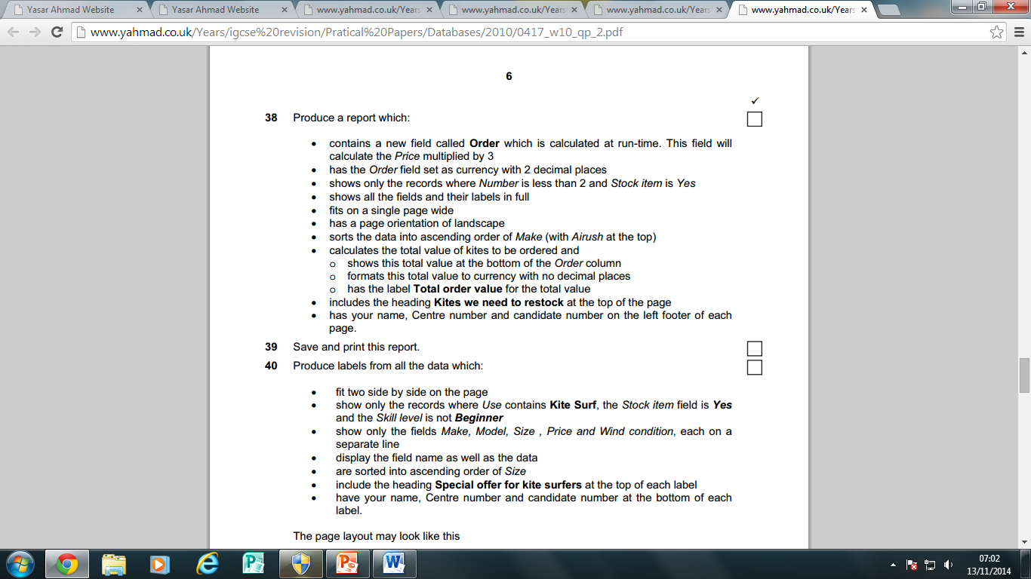

**Search Criteria**

Number – **<2**

Stock item- **yes**

**R**

**R**

**R**

**R**

**R**

**Q**

**Q**

**Q**

**Q**

**Q**

Discount_Value**:[**Price**]**\***[**Discount_applied**]/**100

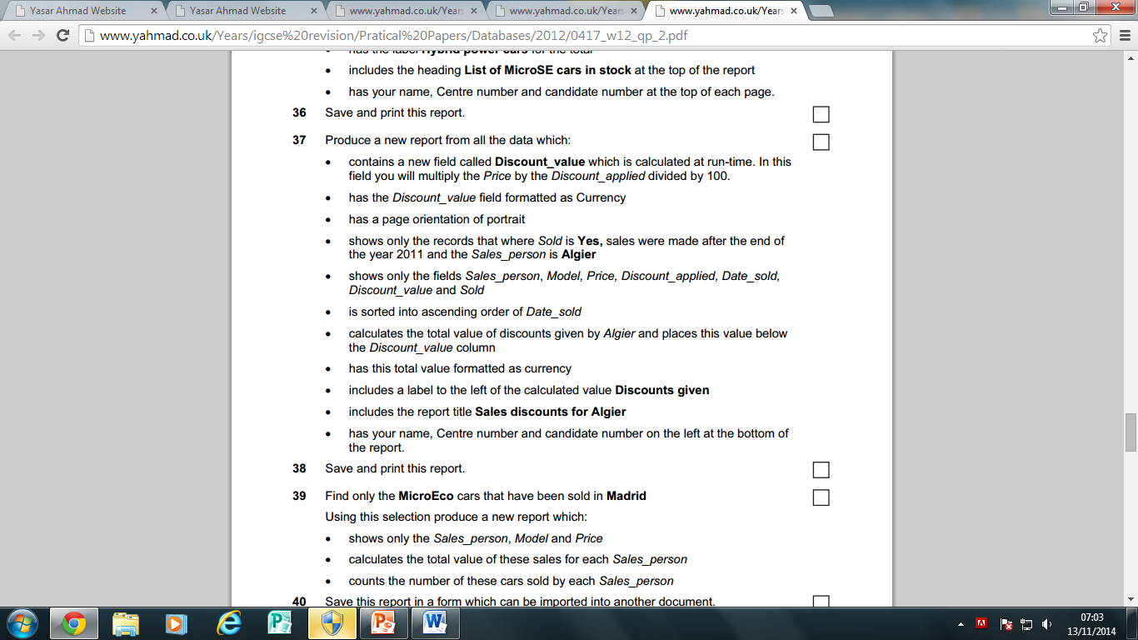

**R**

**Q**

**R**

**R**

**R**

**R**

**R**

**Q**

**Q**

**Q**

**Q**

**Search Criteria**

Sold

**Yes**

Date_sold

**>31/12/2011**

Sales_person

**Algier**

Turbine_Capacity**:[**Capacity**]/[**Number**]**

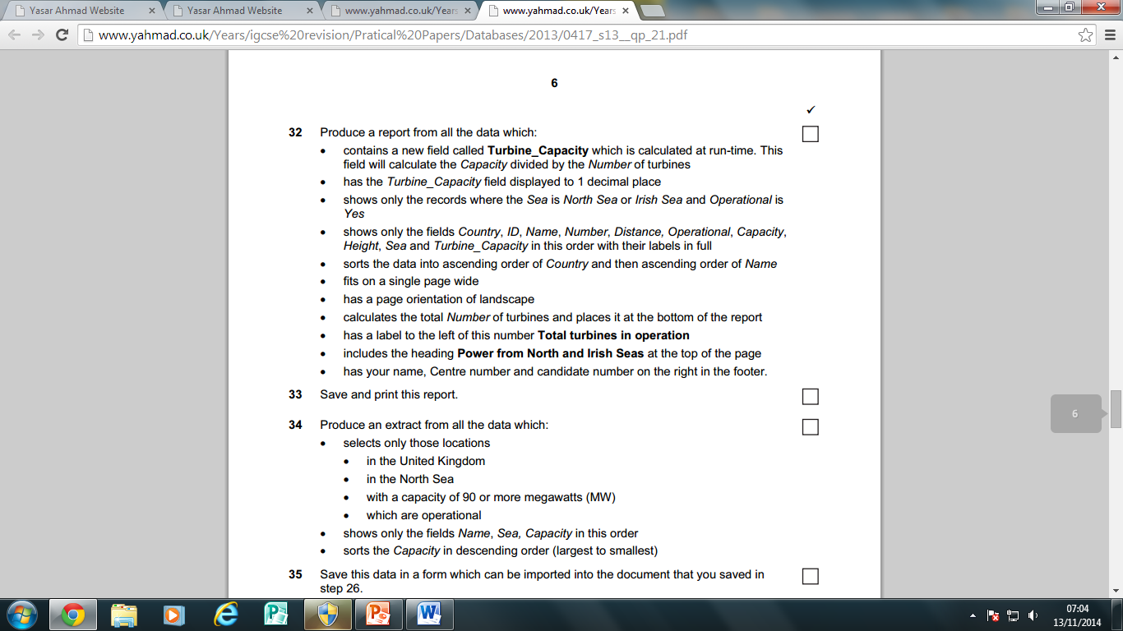

**R**

**R**

**R**

**R**

**R**

**R**

**Q**

**Q**

**Q**

**Q**

**Q**

**Search Criteria**

Sea

**North Sea or Irish Sea**

Operational

**Yes**